
VItyarthi project
Project title-:Simple banking system
Name-:Ramish areef ahmad
Reg no.-:25bce11210

Introduction
- The Simple Banking System is a console-based software application developed using the Java programming language. Financial institutions require robust systems to manage customer data and transactions efficiently. This project serves as a simulation of core banking operations, demonstrating the practical application of Object-Oriented Programming (OOP) principles.
-The system provides a secure and user-friendly interface allowing users to create accounts, perform deposits and withdrawals, and view transaction histories in real-time. It bridges the gap between theoretical programming concepts and practical software development.

Problem statement
-Managing bank accounts manually is tedious, prone to calculation errors, and lacks instant accessibility to transaction history. Furthermore, students learning Java often struggle to visualize how Classes and Objects interact in a persistent state application.
-The problem addressed by this project is twofold:
1) To create a basic automation tool for banking activities (Account creation, money management).
2) To provide a clear, working model of how data encapsulation and state management work in Java.

Functional requirement
-Account Creation: Users must be able to generate a new account with a unique Account Number, Name, and a secure 4-digit Pin.
- Authentication: Users must be able to log in using their specific Account Number and PIN.
- Deposit Funds: The system must accept positive numeric values to increase the account balance.
- Withdraw Funds: The system must decrease the account balance, provided sufficient funds exist.
- Transaction History: The system must record and display a chronological list of all actions (Opening, Deposit, Withdrawal).
- Balance Inquiry: Users must be able to check their current available balance.

Non-functional requirement
- easy for non-technical users to navigate.
- ensuring the PIN is 4 digits, preventing negative withdrawals.
- ensuring instant response times for data retrieval.
- Access to account features is restricted by a PIN verification step providing good safety.

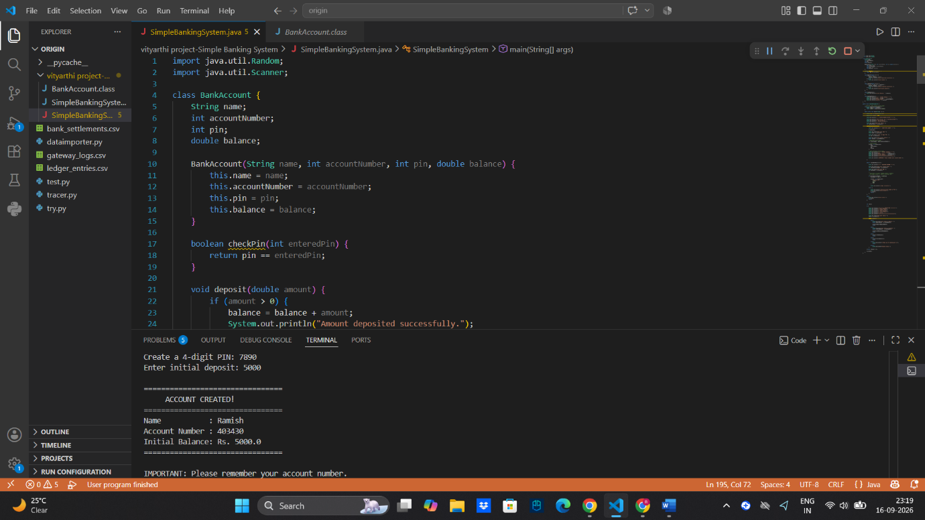

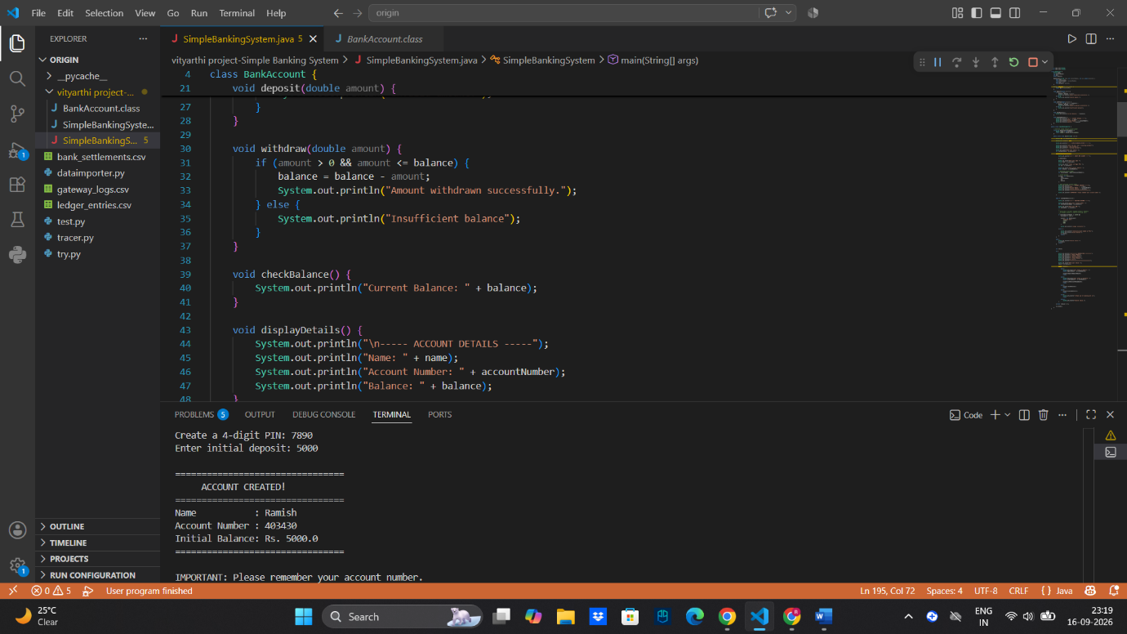
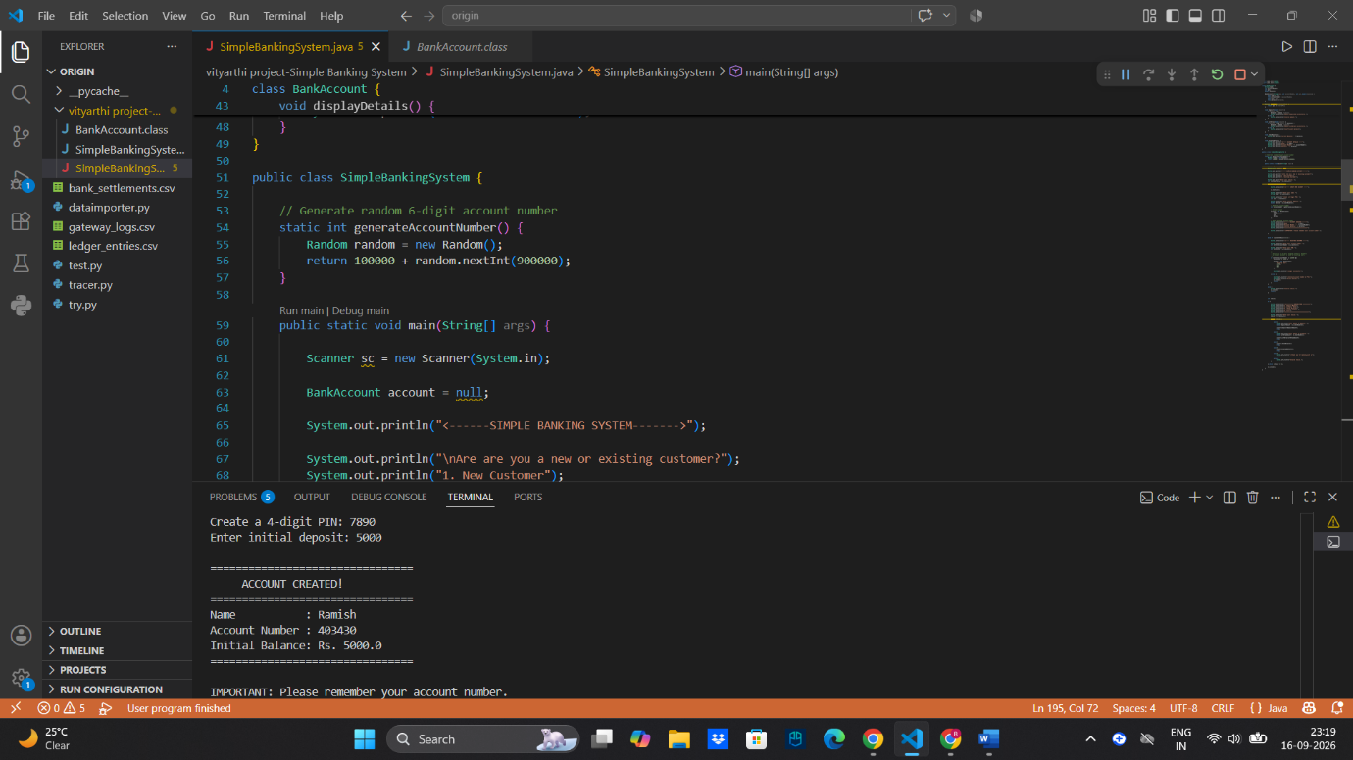
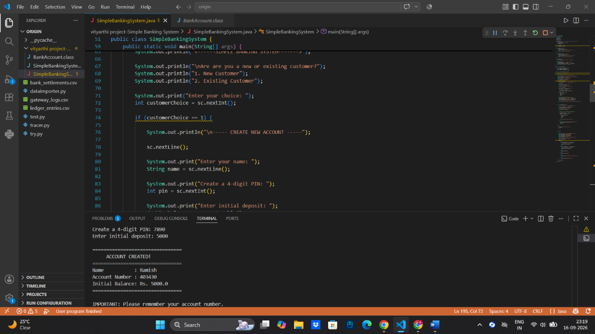
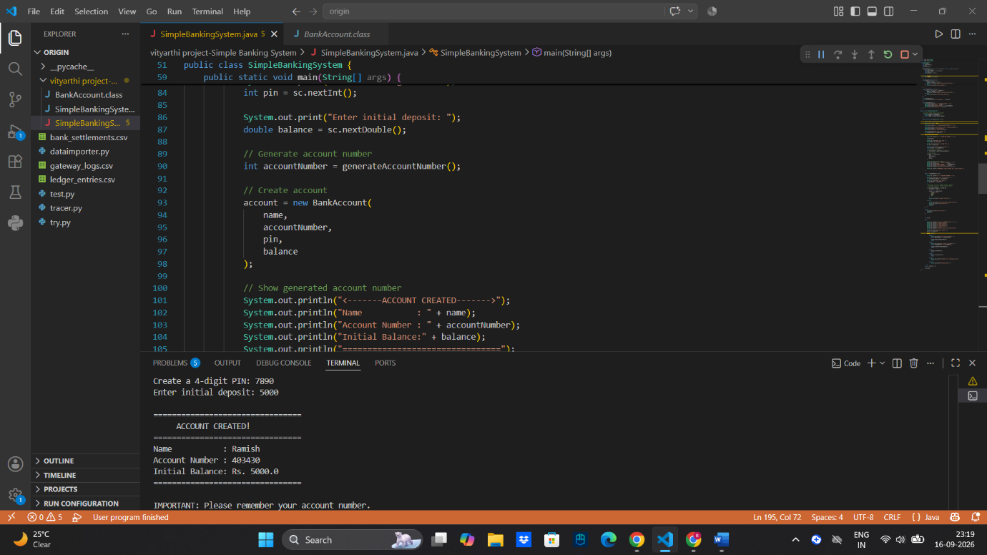
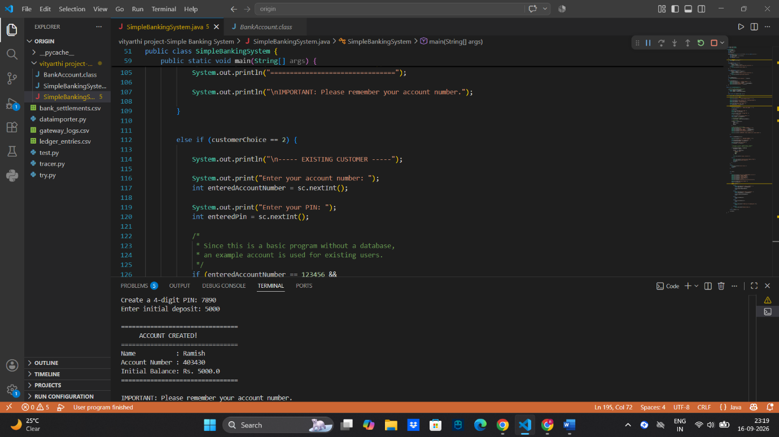
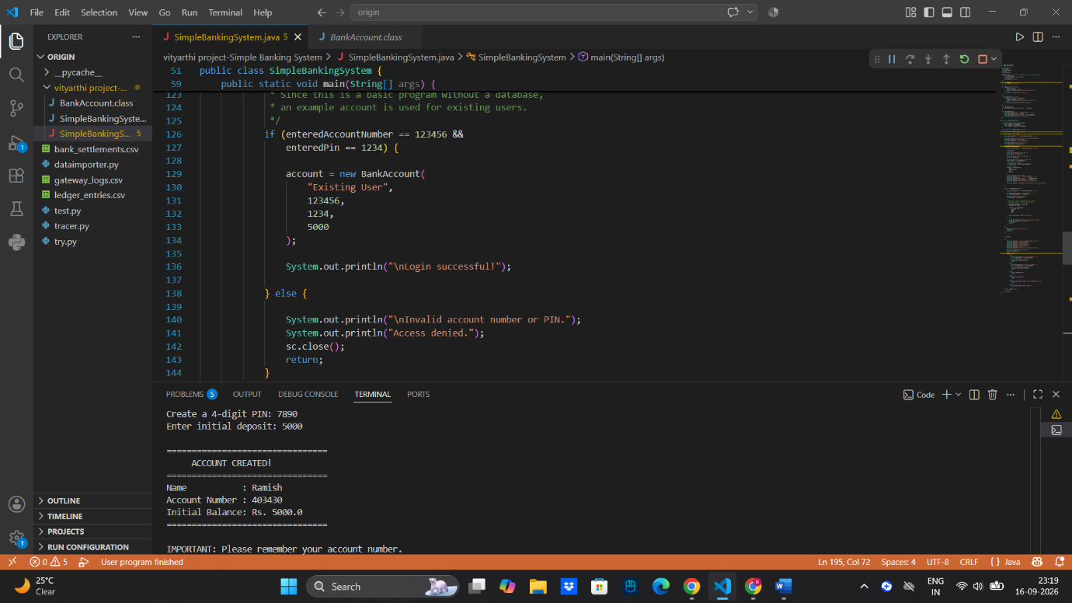
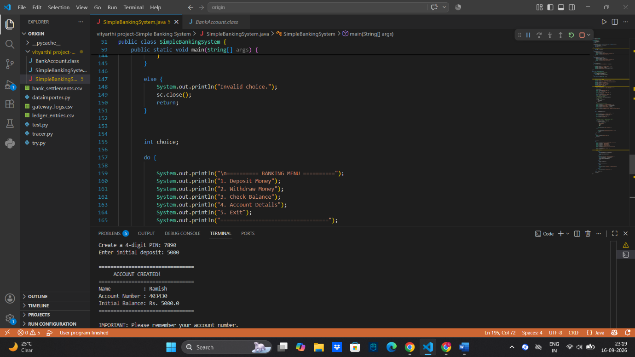
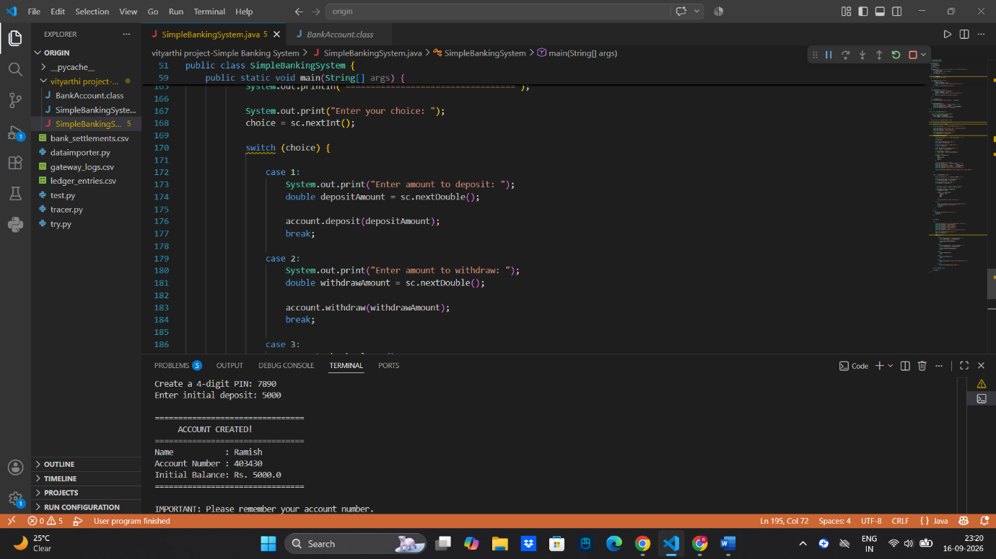
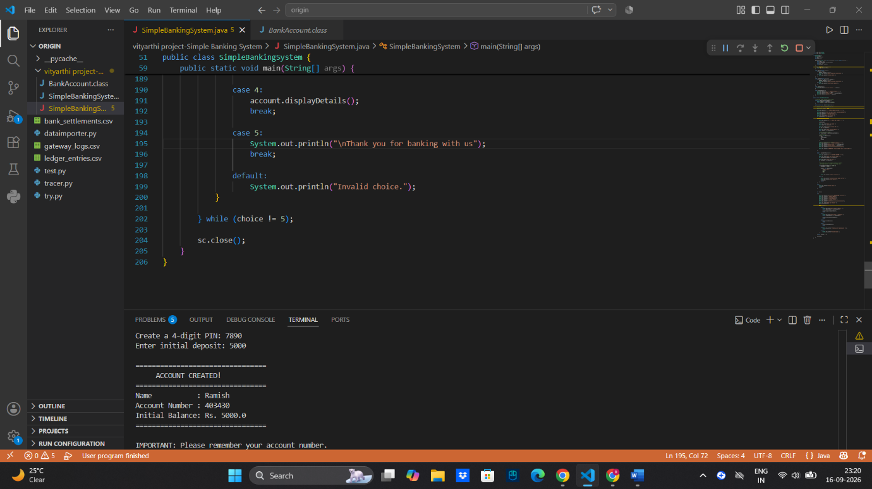
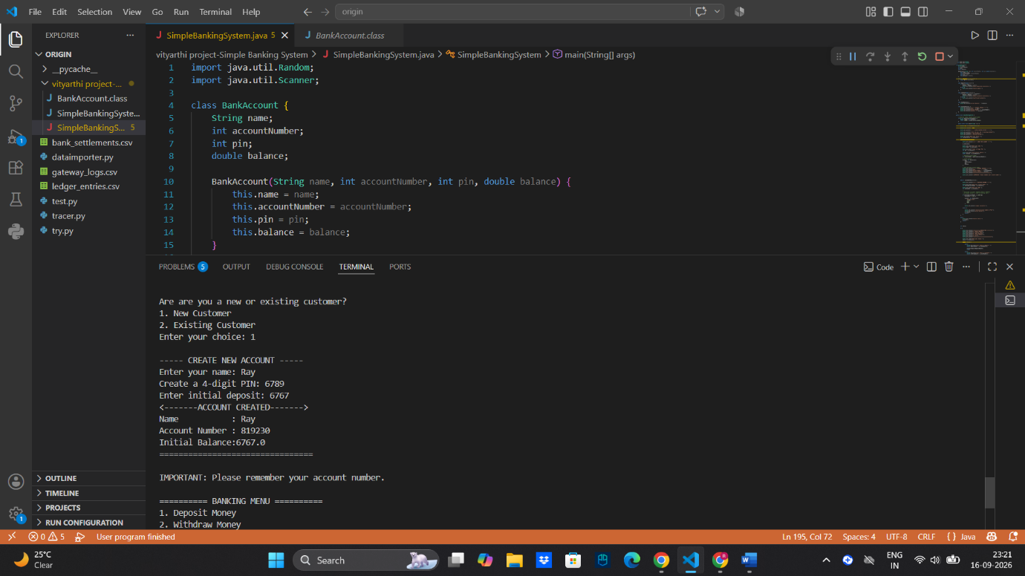
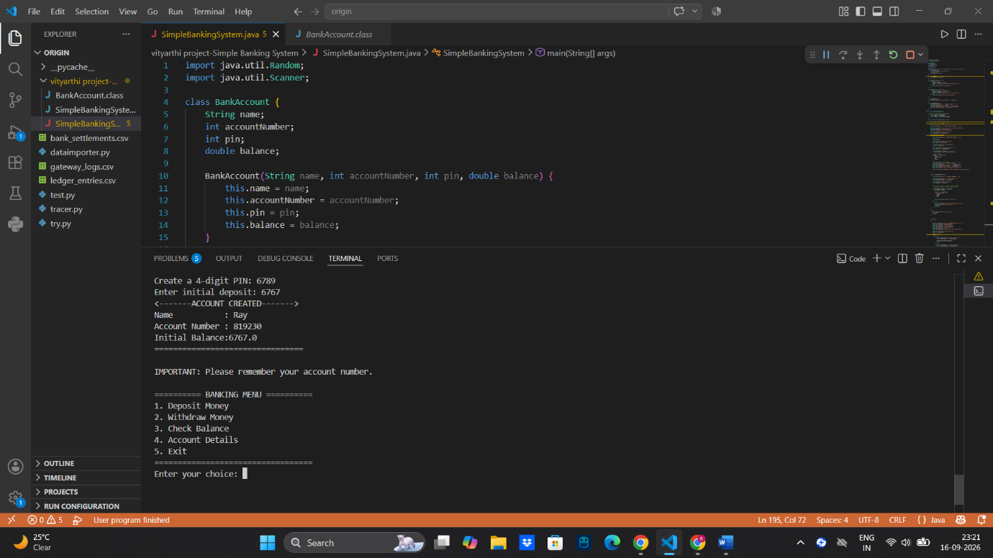
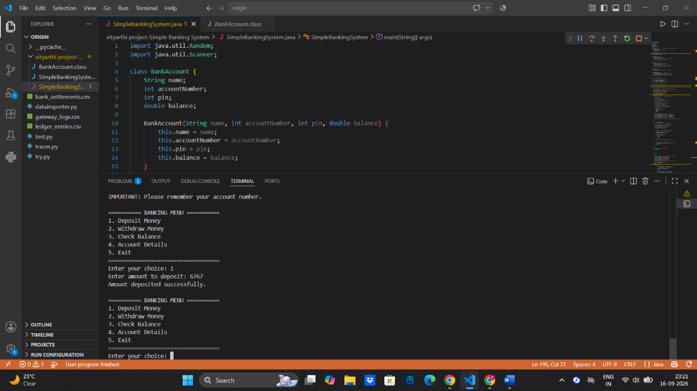
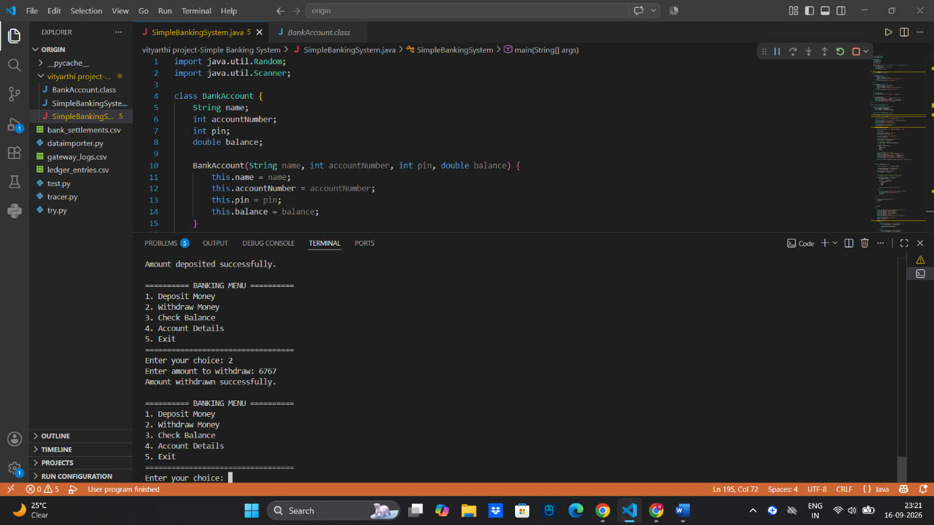
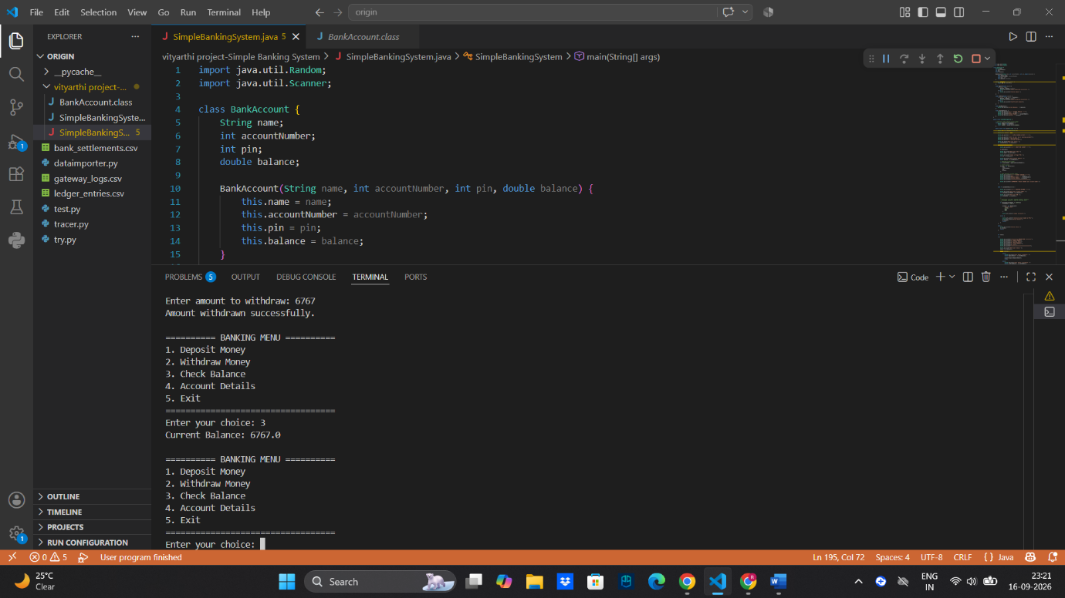
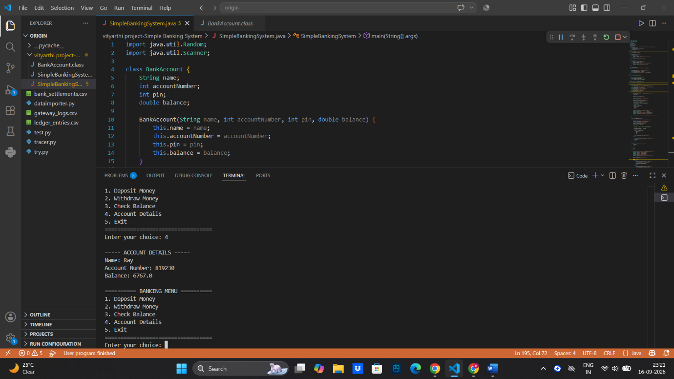
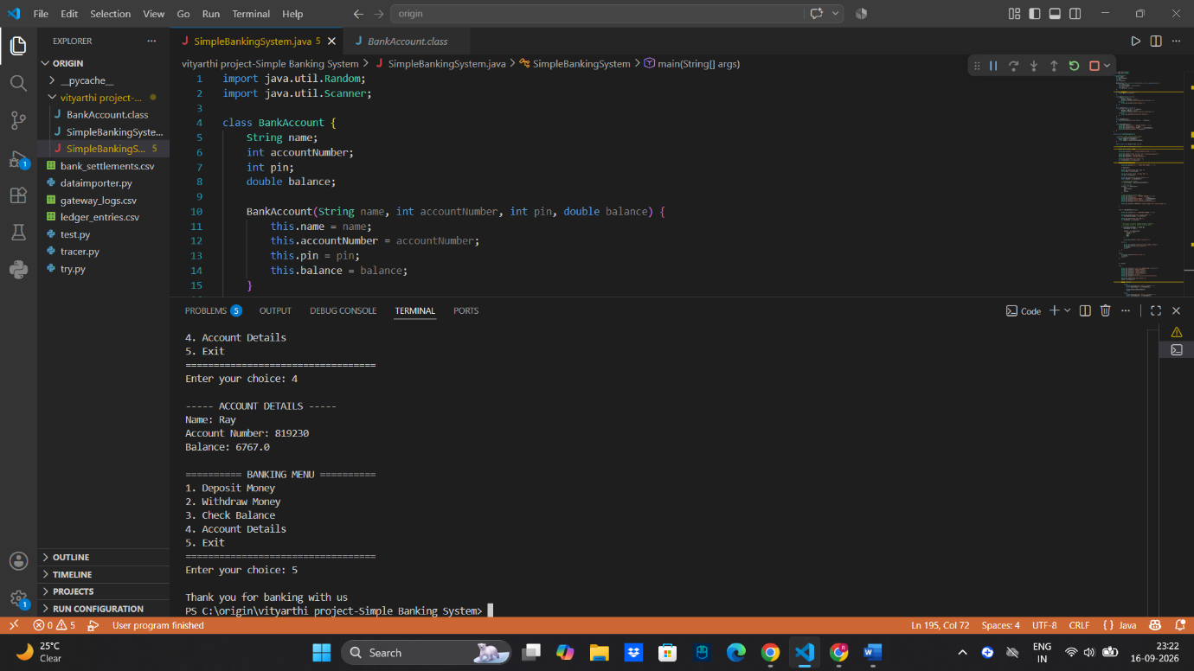

Challenges faced
- The biggest challenge is that data is stored in variables. Once the Java Code stops, all account data is lost.
- Handling scenarios where the user enters alphabets instead of numbers for the deposit amount caused crashes initially. This was solved using try-except logic (though basic validation is implemented, full exception handling is a future step).
- Ensuring the random number generator doesn't produce a duplicate ID (though statistically unlikely with a small sample size).

Future Enhancements
- Implement pickle or SQLite to save customer data permanently so it persists after the program closes.
- Add a feature to transfer funds from one account object to another using the Account Number.

